**Memory management commands**

Memory management is crucial in operating systems as it handles the allocation, management, and optimization of the system's memory resources

1. **Free:**

* The free command displays the amount of free and used memory in the system, including physical and swap memory.
* It provides a snapshot of memory usage, showing total, used, free, shared, buffer/cache, and available memory.

#free (one time snapshot of memory)

#free –h (In human readable format)

#free –m (In Megabytes)

#free -g (In gigabytes)

#free –s <interval> (Continuously display memory usage updates at a specified interval (in seconds)

**1. You are running a web server, and it's becoming unresponsive during high traffic. You suspect the server is running out of memory. How would you use the free command to confirm this?**

->free –h

**Output:**

total used free shared buff/cache available

Mem: 16Gi 14Gi 200Mi 500Mi 2Gi 1Gi

Swap: 2Gi 1Gi 1Gi

**Used memory (14Gi)** is high, leaving only **200Mi free**.

**Available memory (1Gi)** is low, indicating that the system is nearing its memory capacity.

**Swap (1Gi used)** indicates that the system is already using some swap space, which can slow down the server as swapping is much slower than accessing RAM.

1. **mkswap**

The mkswap command is used to set up a swap area on a specified device or file.

Swap space is a portion of the hard drive used as virtual memory, allowing the system to handle more processes than it can fit in RAM alone.

->sudo mkswap /dev/sdX

->sudo mkswap /path/to/swapfile

You want to increase the swap space on your server because your application is consuming more memory than available. Describe how you would use the mkswap command to create a new swap file.

1. First, I would create a swap file using the dd command to allocate the required space (e.g., 2GB):

->sudo dd if=/dev/zero of=/swapfile bs=1M count=2048

1. **Set the correct permissions for the swap file:**

->sudo chmod 600 /swapfile

1. use the mkswap command to set up the swap file:

->sudo mkswap /swapfile

1. Finally, I would enable the swap file using:

->sudo swapon /swapfile

**1. You have added a new disk to your server, and it has a partition /dev/sdb1 that you want to use for swap space instead of creating a swap file. How would you format this partition for swap and enable it?**

->sudo mkswap /dev/sdb1

->sudo swapon /dev/sdb1

**Verify that the swap partition is active**

->swapon --show

->free –h

**2. You are managing a busy production server that is running out of memory. The server already has 4 GB of swap, but it is completely used up. You need to add an additional 2 GB of swap without disrupting the server's operation.**

**Check existing swap**:

->swapon --show

->free –h (Verify the current swap space is 4 GB and fully utilized)

**Create a new 2 GB swap file**:

->sudo dd if=/dev/zero of=/newswapfile bs=1M count=2048

sudo chmod 600 /newswapfile (set permission)

sudo mkswap /newswapfile (format the swap file)

sudo swapon /newswapfile (enable swap file)

1. **swapon**

The swapon command is used to enable devices and files for swapping, allowing the operating system to use them as swap space.

->sudo swapon /dev/sdX

->sudo swapon /path/to/swapfile

**1. Your system is using an old 1 GB swap partition on /dev/sda3. You have added a new 4 GB swap partition on /dev/sdb2. How would you replace the old swap partition with the new one without affecting system performance?**

**Disable the old swap partition**:

sudo swapoff /dev/sda3

**Format the new partition /dev/sdb2 as swap**:

sudo mkswap /dev/sdb2

**Activate the new swap partition**:

sudo swapon /dev/sdb2

**2. You have two swap areas on your system, one on an SSD and another on an HDD. You want the system to use the SSD-based swap area first because it is faster. How would you adjust the priority of swap spaces using mkswap and other commands?**

**Check current swap areas**:

->swapon –show

**Set priority when activating the SSD swap space**:

(For the SSD-based swap (assuming it's on /dev/nvme0n1p1))

->sudo swapon /dev/nvme0n1p1 --priority 100

**Set a lower priority for the HDD swap space**:

(For the HDD-based swap (assuming it's on /dev/sda2))

->sudo swapon /dev/sda2 --priority 10

1. **vmstat**

The vmstat (Virtual Memory Statistics) command in Linux is a powerful tool that provides information about processes, memory, paging, block I/O, traps, and CPU activity.

It helps system administrators monitor the system's performance and identify potential bottlenecks in real-time.

->vmstat

**Output:**

procs -----------memory---------- ---swap-- -----io---- -system-- ------cpu-----

r b swpd free buff cache si so bi bo in cs us sy id wa st

1 0 0 90400 30524 102524 0 0 20 10 50 102 2 1 95 2 0

**procs:**

* **r**: The number of processes waiting for CPU time (run queue).
* **b**: The number of processes in an uninterruptible sleep (typically I/O wait).

**memory:**

* **swpd**: Amount of swap memory in use.
* **free**: Amount of idle memory.
* **buff**: Memory used for buffers.
* **cache**: Memory used for page cache.

**swap:**

* **si**: Swap-in from disk (the amount of data being read from swap).
* **so**: Swap-out to disk (the amount of data being written to swap).

**io:**

* **bi**: Blocks received from a block device (read I/O).
* **bo**: Blocks sent to a block device (write I/O).

**system:**

* **in**: Number of interrupts per second.
* **cs**: Number of context switches per second.

**cpu:**

* **us**: Time spent running user processes.
* **sy**: Time spent running system (kernel) processes.
* **id**: Time spent idle.
* **wa**: Time spent waiting for I/O.
* **st**: Time stolen from a virtual machine (hypervisor-related

**1. Your web server is running slowly, and users are complaining about performance issues. You run the vmstat command and observe high values in the us (user) and sy (system) columns under the CPU section. What does this indicate, and how would you investigate further?**

->vmstat

High us value: Indicates that the CPU is spending a lot of time processing user applications.

High sy value: Indicates the system is spending significant time handling kernel tasks (e.g., I/O, system calls).

1. **You notice a high number of context switches (cs column) while running vmstat. What does this indicate, and how can you investigate further?**

->vmstat

A high number of context switches (cs) indicates that the CPU is frequently switching between processes. This can lead to performance degradation if excessive.

Check for many short-lived processes using top or ps.Frequent process creation and termination could be causing high context switches.

**Use pidstat** to monitor the number of context switches per process:

->pidstat -w 1

**Assignment 3 - Memory Management Commands**

1) Setup additional swap space in the system to solve low memory issue. The swap which you added should be available post reboot.

->sudo fallocate –l 2G /swapfile (creating swap file)

->sudo chmod 600 /swapfile (Giving permission of read, write to user on swap file)

->sudo mkswap /swapfile (Formating swap file for swap space

->sudo swapon /swapfile (Activating swap file)

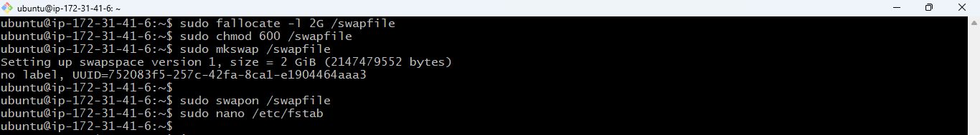

**Verifying the swap space**

->free -h

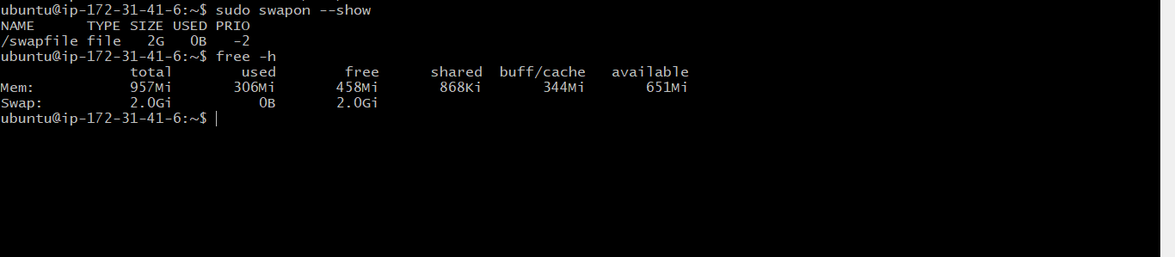

**Making swap space available after reboot(permanent)**

->/swapfile none swap sw 0 0

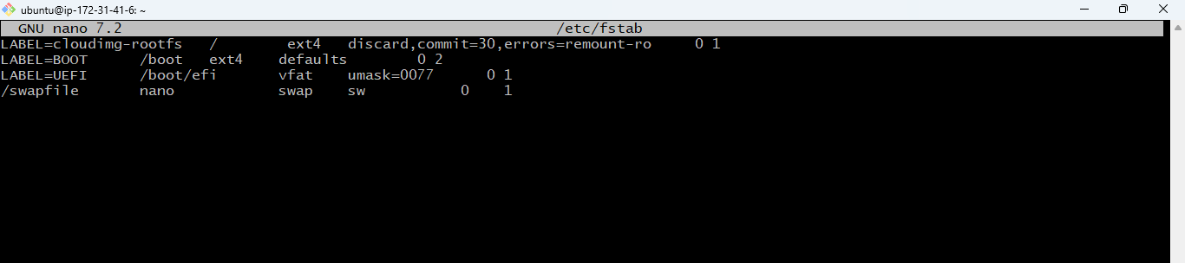

2) Find out the number of process is in run queue and blocking queue

-> ps -eo state | grep -c 'R' (Run queue)

-> ps -eo state | grep -c 'D' (Blocking queue)

